**AI-based skin disease monitoring and recognizing systems by image processing models** We provide our best service in the easiest way!

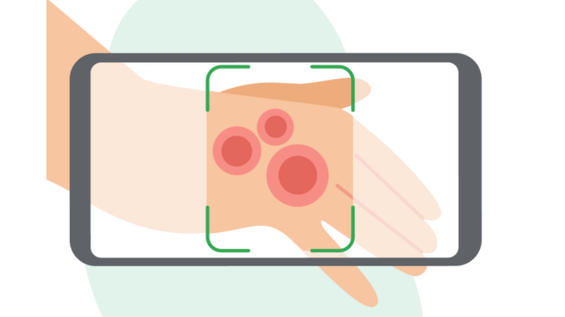

|  |  |
| --- | --- |
| **Submitted To**  **MR. ANWARUL ISLAM**  Lecturer  Department of CSE | **Submitted By**  **Md. Parvej Hossain**  ID: 181002085  **Mohammad Shahjalal**  ID: 181002079  **Nusrat Farhana**  ID: 181002183  **Naima Sultana Swarna**  ID: 181002021  Section: 181_DC  Department of CSE |

**Group Name – Webstack**

**TABLE OF CONTENTS**

1. Planning … 5
2. Project identification and Selection ……………………………….. 5
   1. Team information (manager, leader, and writer)………………..... 5
   2. Identification of projects (Ranking and Selection of Project)…….. 5
   3. Describing Project (Rank), scope, advantage, Complexity, Market

Analysis ………………………………………………………....... 6

* 1. Selected Project ………………………………………………….. 8

1. Planning 9
2. Initiating and Planning IS project ………………………………... 9
   1. Describe project scope, alternatives, feasibility ………………. 9
   2. Divide project into tasks … …………………………………… 9
   3. Estimate resource requirements and create a resource plan……………………………………………………….......... 10
   4. Develop a preliminary Plan ……………………...…………..... 10
   5. Develop a communication plan ……………………………….. 11
   6. Determine standards and procedures ……………………...…... 11
   7. Identify and assess risk………………………………………… 11
   8. Create a preliminary budget …………………………………... 12
   9. Develop a statement of work …………………………...……... 12

1.10 Set baseline project plan………………………………...…….. 12

1. Analysis........ ……………………………………………………………………….13
2. Requirement Determination…………………………………..…... 13
   1. Prepare an interview guide 13

a. Interview Outline

b. approximate time: 1.5 hours

c. Questions

d. Answers

* 1. Analysis and review of the interview 15

2. Analysis……………………………………………………………………………..16

1. Requirement Analysis……………………………………………...16
   1. Requirement Analysis………………………………………… 16
   2. Diagnostics information analysis 16

Primary treatment suggestions 17

* 1. Test suggestions 17
  2. Tests result analyzing the disease 17
  3. Possible solution suggestions & Medicine Solution suggestions 18

Medicine suggestions 18

1. Data Design . . . . . . . . . . . . . . . . . . . . . . . . . . . . . . . . . . . . . . . 19
   1. After 3NF Normalization……………………………………. 19
   2. Use case Diagram 22
   3. Sequence Diagram 23
   4. Class Diagram 24
2. Implementation: Prototype . . . . . . . . . . . . . . . . . . . . . . . . . . . . 25
   1. Desktop – 01 25
   2. Desktop – 02 26
   3. Desktop – 03 27
   4. Desktop – 04 28
   5. Desktop – 05 29
3. Maintenance. . . . . . . . . . . . . . . . . . . . . . . . . . . . . . . . . . . . . . . . 30
   1. Definition 30
   2. Four major activities occur within maintenance 30
   3. Implement the same functionality 31
4. **Planning**
5. **Project Identification and Selection**

**1.1: Team information (manager, leader, and writer)**

|  |  |  |
| --- | --- | --- |
| **Name** | **ID** | **Designation** |
| **Mohammad Shahjalal** | 181002079 | Manager |
| **Parvej Hossain** | 181002085 | Leader |
| **Nusrat Farhana** | 181002183 | Writer |
| **Naima Sultana Swarna** | 181002021 |  |

**1.2: Identification of projects (Ranking and Selection of Project)**

* Research Help desk.
* AI-based Women's safety & Health care.
* Online E-learning platform for children.
* AI-based Fitness app
* AI-based skin disease monitoring and recognizing systems by image processing models

**1.3: Describing Project (Rank), scope, advantage, Complexity, Market analysis:**

|  |  |  |  |  |
| --- | --- | --- | --- | --- |
| **Projects (Rank)** | **Scope** | **Advantage** | **Complexity** | **Market analysis** |
| 1. AI based Women's Safety & Health Care | 1. Heart rate detection using watch  2. fear and danger detection  3. mobile app controlling system  4. Dynamically call on emergency & priority number when women in fear or danger  5.Automatically location detection  6. Give update on health care tips & tricks  7. Doctors’ information according to their location  8. Best hospital information according to user location with different categories.  9. AI based suggestions  10. Ambulance information and cost  11. Accident detection  12. To-Do list facility  13. Prescription copy stored facility and alert system  14. Medicine details | 1. Ensuring women's safety and health  2. organizational benefits  3. Big profitable projects | 1. Very complexed  2. Higher cost project. | 1. In the market there is no app like this.  2. Our project is different from other safety apps or health care apps.  3. We are able to sell these different types of organizations for making money. |
| 2. Online E-learning platform for children. | 1.E-Learning platform some test like (Spell Correction, rearranging, fill in the blanks, selecting correct word & letter from the given picture, select correct picture from the word, matching picture & word, story learn with question & answer part) with audio & video in learning phase.  2. Switching language from English to Bangla or vice versa.  3. Kids can easily picture, draw and color.  4. Kids play games and watch cartoon. | 1. Kids can easily learn from this system.  2. Different types of projects.  3. Organization benefits.  4. Develop the kids' skills and kids will find their interest by gaming & coloring features. | 1. Very complexed  2. Higher cost project. | 1. Our project is different from other E-learning for children.  2 We are able to sell these different types of organizations for making money. |
| 3. Research Help Desk | 1. Finding researchers for research  2. User profile info.  3. Research guideline  4. Paper writing guideline | 1. Students find the good direction  2. Difficult problem solution idea from the expert. | 1. Low complexity  2. Low-cost project | 1.  In the market there is no app like this but some good platforms exist. |
| 4. AI based Fitness app | 1. Step by step Fitness animation & videos  2. Fitness tips  3. Fitness Diet plan  4. Fitness history/progress  5. Calories burn or gain calculation  6. Alert  7. Smart watch  8. Doctor Advice by Robot chat  9. Gym information | 1. User find the good direction  2. Difficult problem solution idea from the expert.  3. Know about gym instruments and exercise. | 1. Comparatively easy  2. Low-cost project. | 1. In the market there is no app like this.  2. Here we include some extra features. |
| 5. Advance futuristic Rideshare platform | 1. Fixed door to door official ride sharing service  2. AI based server control  3. AI control ride withdrawal and next ride control.  4. Arrival and waiting time  5. Integrated server system. | 1. Users reach his/her place within time.  2. Users feel safe and tension free service with reasonable price. | 1. Comparatively easy  2. Low-cost project. | 1. In the market there is no app like this.  2. Our project is different from other rideshare apps or health care apps.  3. We are able to sell these different types of organizations for making money. |
| 6. AI-based skin disease monitoring system project | 1. Monitoring the health of skin diseases by using image processing such as skin rash, pimple, acne, blister, hives, Scalp Psoriasis etc.  2. It gives several general treatment suggestions to the user such as medicine, therapy, or doctor suggestions etc.  3. App and web-based project.  4. FAQ | 1. Provide people’s safety  2. Identify the skin disease by prediction, so that people save money.  3. Big profitable projects  4. Give an optimal treatment suggestions. | 1. Comparatively is so much hard  2. High-cost project. | 1. In the market there is no app like this.  2. Our project is very unique and applicable to people.  3. We are able to sell these different types of organizations for making money. |

**1.4: Selected project:**

“**AI-based skin disease monitoring and recognizing systems by image processing models”**

**1. Planning**

1. **Initiating and Planning IS project**

**1.1: Describe project scope, alternatives, feasibility:**

**Project scope:**

1. Monitoring the health of skin diseases by using image processing such as skin rash, pimple, acne, blister, hives, Scalp Psoriasis, etc.

2. It gives several general treatment **suggestions** to the user such as medicine, therapy, or doctor suggestions, etc.

A. User details: e. g, *name, phone, *age, gender,

B. Symptoms of the disease

C. Symptoms duration

D. Previous experience of the disease

E. Side effect of other health problems of humans.

F. Suggest the tests according to the disease which is predicted by image processing.

G.

3. App and web-based project.

4. FAQ

**Alternatives:**

1. In the market there is no app like this.

2. Our project is different from other safety apps or health care apps.

3. We can sell these different types of organizations for making money.

**Feasibility:**

1. It’s easy to use using a phone/ web page.
2. Easily identify skin disease anywhere you have.
3. Primary treatment idea.
4. It’s used for survey purposes of skin disease.
5. It can be used for learning purposes e. g, further study.

**1.2: Divide project into tasks:**

1. Image segmentation: various disease spots finding using k-means algorithm
2. Feature extraction
3. Construction of development environment
4. Database design:

|  |  |
| --- | --- |
| Data table name | Function description |
| Typical Images | Storing information on typical images of diseases, including the categories of diseases, image  names, descriptions and image storage paths |
| Knowledge | Store basic information about diseases, including disease category, name of diseases, keywords  for identification (location and time of disease) |
| Rules | Store reasoning rules information, including reasoning disease category, parent node, left child  rule, right sub rule, rule type, rule description, regular image storage path |
| Contents | Detailed information about plant diseases, such as summary, typical symptoms, control  methods, etc. |
| Class information | The category of information stored, such as disease, etc. |

1. System architecture
2. Experiments and analysis
3. Conclusion
4. Identify all stakeholders
5. Define roles and responsibilities
6. Developed a Web page/app development

**1.3. Estimate resource requirements and create a resource plan.**

|  |  |
| --- | --- |
| Estimate resource requirements | Resource plan |
| Images of skin disease | Collect images from the web resource |
| Information/data of skin disease | Collect data from the web resource |
| Android apps | Create an android app |
| Web site | Create an android app |

**1.4: Develop a preliminary schedule:**

|  |  |
| --- | --- |
| **Task** | **Preliminary schedule** |
| Image segmentation | 1 week |
| Feature extraction | 1 week |
| Construction of development environment | 1 week |
| Database design | 2 week |
| System architecture | 1 week |
| Experiments and analysis | 1 week |
| Conclusion | 2 day |
| Identify all stakeholders | 1 week |
| Define roles and responsibilities | 1 week |
| Developed a Web page/app development | 1 week |

**1.5: Develop a communication plan.**

1. Every week Tuesday from 10 am - 12 am.
2. Zoom or physical platform

**1.6: Determine standards and procedures.**

1. Standards and Procedures for **Team Performance**, including such general project practices as the code of conduct and standard project terminology, meetings, change control procedures (including the use of Change Requests and Decision Requests), and risk management.
2. Standards and Procedures for **Cost/Schedule Management**, including organizing the work, project monitoring, project accounting, and cost/schedule analysis.
3. Standards and Procedures for **Data Management**, including the project library, document identification, document structure and style, and document preparation.
4. Standards and Procedures for **Configuration Management**, including identifying, controlling, maintaining, and reporting on configuration items.
5. Standards and Procedures for **Quality Management**, including such things as: walk-throughs, reviews, audits and inspections, handling and storing, packaging and shipping, and procedures for eliminating the cause of problems.

**1.7: Identify and assess risk:**

■ **Project size**

Team size: In this project, we required at least four members.

Project duration: at least 2 months

Programming effort: App developer, Web developer, and Project analyzer.

■ **Project structure**

New vs. renovated system: This project is a totally new system.

Management commitment:

User perceptions:

■ Development group

Familiarity with platform:

Software: Java, JavaScript, Android studio, etc.

Development of similar systems: till now there is no app.

■ User group:

Familiarity with IS development process:

Application area: End-to-end users use this app or website.

Use of similar systems:

**1.8: Create a preliminary budget: 100k**

**1.9: Develop a statement of work:**

We chose a project namely “**AI-based skin disease monitoring and recognizing systems by image processing models”** because a number of the people who have skin diseases but won't go to doctors directly, try to take some medicine from any pharmacy, and take random medicine where they have no idea about the disease and medicine. They don't know that it is good medicine for that type of disease or not. So, we work to predict the disease and give an optimal treatment solution suggestion so that people get well soon. It helps people to save money, where people waste his/her money by buying unwanted/fake medicine. Our project will give detailed information about skin disease and treatment suggestions.

**1.10: Set baseline project plan:**

A major outcome of our project people is able to identify their skin problems and get suggestions from our project.

1. **Analysis:**
2. **Requirement Determination**

**2.1: Prepare an interview guide**

**a. Interview Outline**

**b. approximate time: 1.5 hours**

**c. Questions**

**d. Answers**

|  |  |
| --- | --- |
| Interview Outline | |
| Interviewee: User | Interviewer: Swapnil Khan Shahjalal |
| Location/Medium: Shewrapara, Mirpur, Dhaka  Office, conference room,  or phone number | Appointment Date: 29/12/21  Start Time: 3.00 pm  End Time: 4.30 pm |
| Objectives:  What data to collect  On what to gain agreement  What areas to explore | Reminders:  Background/experience of interviewee  Known opinions of interviewee |
| Agenda:   * Introduction * Background on Project * Overview of Interview   + Topics to Be Covered   + Permission to Record | Approximate Time:  1 minute  2 minutes  1 minute |
| Topic 1 Questions | 5 minutes |
| Topic 2 Questions | 7 minutes |
| Summary of Major Points | 2 minutes |
| Questions from Interviewee | 5 minutes |
| Closing | 1 minute |
| Interviewee: Mohammad Shahjalal | Date: 20 September 2021 |
| Questions: | Notes: |
| (Open-ended)  Question:   1. What do you want from this project? 2. What is the main feature of your project? 3. How do I diagnose the disease? 4. A symptom might appear in several diseases. What is the best way to deal with this situation? 5. How would you give the suggestions for identified diseases? 6. How many possible solutions do you have? 7. What will be the primary treatment? 8. What is the budget of your project? 9. What is the delivery time of your project? 10. How can we help you find what you are looking for in your system? 11. What are your system goals? 12. How important is security around your AI-based skin disease monitoring by facial expression and image processing models project? | Observations:  Answer:   1. In this project, I will identify skin disease by monitoring disease images and identifying the illness weight of the patient by facial expression. It also analyzes the test result for giving appropriate suggestions of treatment. It reduced the time and cost also. 2. Find the skin disease and give the expert suggestion of treatment to the user. Such as -  * Disease diagnostics:  1. Diagnose the situation by facial expressions and monitoring images/symptoms of the disease. 2. Give some tests for analyzing the disease. 3. Test result analyzing 4. 2 possible solution 5. Simple suggest 6. 100K 7. within 3 month 8. Firstly I want a navigation bar on top of my page or app and the middle of the point has some pictures of our organization's activities and then I have shown my facilities and then our organization’s introductions and then end. 9. My system goal is benefits of user & organization. 10. It is very much important is security around my AI-based skin disease monitoring by facial expression and image processing models project |

# **2.2: Analysis and review of the interview.**

**Ans:**

|  |  |
| --- | --- |
| Requirements | Analysis and Review |
| 1. Diagnostics information analysis | First of insert user information (name, age, gender, phone number).Then user Symptoms duration and previous experience of the disease. |
| 1. Tests suggestions | Test suggestions (blood test, skin biopsy, skin culture lab test as output). |
| 1. Tests analyzing | Test report as a input and advice primary treatment |
| 1. Medicine suggestions | Test report as a input and Identification medicine for solving disease |

# 

**2. Analysis:**

1. **Requirement Analysis**

# 2.1: Requirement Analysis

|  |  |
| --- | --- |
| **Functional Requirement:** | **Non-Functional Requirement:** |
| 1. Diagnostics information analysis 2. Tests suggestions 3. Tests analyzing 4. Medicine suggestions 5. FAQ | 1. User Registration 2. Security 3. Reliability 4. Fast |

* 1. **Diagnostics information analysis:**

**DATA:**

* *name, *age, gender, phone no.
* Symptoms
* Duration
* Previous experience of the disease
* Image
* Symptoms from dataset
* **Output**: list of symptoms

**Source:** text input, images of user

**Data Flow:**

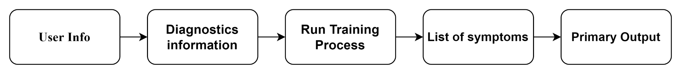

**Primary treatment suggestions:**

**Data:**

* Get the order right.
* Exfoliate once per week.
* Always wear an SPF.
* Drink water, and lots of it.
* Don’t forget your neck and décolletage.
* Double cleanse.
* Use toner.
* Boost your vitamin C.
* Try retinol.
* Hone your moisturizing technique.
* Avoid hot water.
* Eat your skincare (but not the products!).
* Give your face a massage.

**Source:** <https://www.healthline.com/health/skin-disorders#pictures>

**2.3: Test suggestions**

* Identified disease as input
* blood test, Skin biopsy, skin culture lab test as output

**Data Flow:**

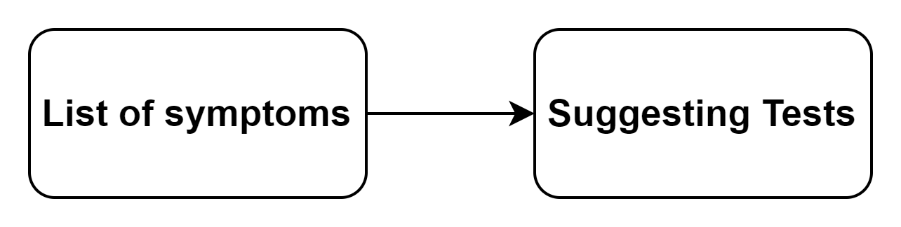

**2.4: Tests result analyzing the disease.**

**Data:**

1. List of symptoms as input
2. Test Report as input
3. Primary treatment take as input
4. Identified medicine for solving disease

**Source:**

[**https://link.springer.com/article/10.1007/s12010-019-03222-8/tables/2?fbclid=IwAR07qmvbs2Nn-EAaFDfwQ826brGP2BgY59C7KhIdrsJ6rAtKdIp7iTlch-M**](https://link.springer.com/article/10.1007/s12010-019-03222-8/tables/2?fbclid=IwAR07qmvbs2Nn-EAaFDfwQ826brGP2BgY59C7KhIdrsJ6rAtKdIp7iTlch-M)

**Data Flow:**

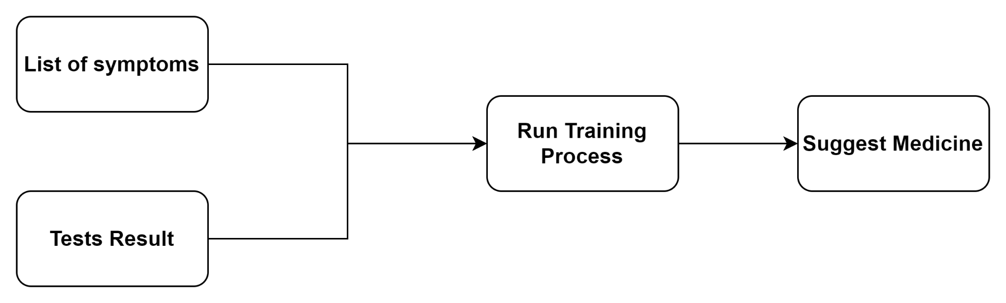

**2.5: Possible solution suggestions & Medicine**

Solution suggestions:

* Avoid sharing utensils, personal items or cosmetics.
* Disinfect objects you use in public spaces, such as gym equipment.
* Drink plenty of water and eat a nutritious diet.
* Sleep seven to eight hours per night.
* Use sun protection to prevent sunburn and other sun damage.
* Wash your hands regularly with soap and water.

**Source:**[**https://my.clevelandclinic.org/health/diseases/21573-skin-diseases#management-and-treatment**](https://my.clevelandclinic.org/health/diseases/21573-skin-diseases#management-and-treatment)

**Medicine suggestions:**

* Tremotyx
* Butenafine
* Cefdinir
* Biafine
* Desonide.

**3. Database Design**

**3.1: After 3NF Normalization**

**Table-1**

|  |  |  |  |
| --- | --- | --- | --- |
| User id | Name | Age | Phone No. |
| 1 | Arifa | 31 | 1719865595 |
| 3 | Ashik | 20 | 1951799925 |
| 4 | Abdullah | 25 | 1967778699 |
| 5 | Swapnil | 20 | 1712696798 |
| 6 | Neelima | 20 | 1119046848 |
| 7 | Shona | 23 | 1559662161 |
| 8 | Parvej | 26 | 1765696718 |
| 9 | Mithu | 30 | 1646924829 |
| 10 | Anower | 30 | 1056610347 |
| 11 | Rasel | 24 | 1411306602 |
| 13 | Tanha | 28 | 1254054841 |
| 14 | Sopna | 28 | 1863014191 |

**Table-2**

|  |  |  |  |  |  |  |  |  |  |
| --- | --- | --- | --- | --- | --- | --- | --- | --- | --- |
| image_id | List of Symptoms | Duration | Previous Experience | Image | analysis_id | Date-time | Image_analysis_suggestions | Primary_Treatment | Test Suggestions |
| 1 | Breakouts on the skin composed of blackheads, whiteheads, pimples, or deep, painful cysts and nodules | 2 | N\A | image/path | 1 | 01/05/2013 | raised bumps | Avoid sharing utensils, personal items or cosmetics. | blood test, Skin biopsy, skin culture lab test |
| 2 | peeling skin | 9 | N\A | image/path | 2 | 02/05/2019 | peeling skin | Disinfect objects you use in public spaces, such as gym equipment. | blood test, Skin biopsy, skin culture lab test |
| 3 | Eczema | 2 | N\A | image/path | 3 | 06/09/2020 | Eczema | Sleep seven to eight hours per night. | blood test, Skin biopsy, skin culture lab test |
| 4 | Cellulitis | 5 | N\A | image/path | 4 | 06/05/2021 | Cellulitis | Use sun protection to prevent sunburn and other sun damage. | blood test, Skin biopsy, skin culture lab test |
| 5 | Measles | 5 | N\A | image/path | 5 | 09/12/2015 | Measles | Wash your hands regularly with soap and water. | blood test, Skin biopsy, skin culture lab test |
| 6 | Red, painful, fluid-filled blister that appears near the mouth and lips | 4 | N\A | image/path | 6 | 02/02/2019 | Cold sore | Wash your hands regularly with soap and water. | blood test, Skin biopsy, skin culture lab test |
| 7 | Characterized by watery, clear, fluid-filled area on the skin | 2 | N\A | image/path | 7 | 07/05/2019 | Blister | Avoid sharing utensils, personal items or cosmetics. | blood test, Skin biopsy, skin culture lab test |
| 8 | Itchy, raised welts that occur after exposure to an allergen | 11 | N\A | image/path | 8 | 12/11/2020 | Hives | Disinfect objects you use in public spaces, such as gym equipment. | blood test, Skin biopsy, skin culture lab test |
| 9 | facial flushing, raised, red bumps, facial redness, skin dryness, and skin sensitivity | 3 | N\A | image/path | 9 | 18/01/2019 | Rosacea | Drink plenty of water and eat a nutritious diet. | blood test, Skin biopsy, skin culture lab test |
| 10 | Eczema | 5 | N\A | image/path | 3 | 29/08/2019 | Eczema | Sleep seven to eight hours per night. | blood test, Skin biopsy, skin culture lab test |
| 11 | Cellulitis | 1 | N\A | image/path | 4 | 28/11/2020 | Cellulitis | Use sun protection to prevent sunburn and other sun damage. | blood test, Skin biopsy, skin culture lab test |
| 12 | Measles | 8 | N\A | image/path | 5 | 05/05/2019 | Measles | Wash your hands regularly with soap and water. | blood test, Skin biopsy, skin culture lab test |
| 13 | Lupus | 6 | N\A | image/path | 10 | 04/09/2021 | Lupus | Avoid sharing utensils, personal items or cosmetics. | blood test, Skin biopsy, skin culture lab test |
| 14 | Vitiligo | 2 | N\A | image/path | 11 | 16/12/2021 | Vitiligo | Disinfect objects you use in public spaces, such as gym equipment. | blood test, Skin biopsy, skin culture lab test |

|  |  |  |  |
| --- | --- | --- | --- |
| result-id | Test result | Final Medicine suggestions | Flag |
| 1 | raised bumps | Tremotyx | 0 |
| 2 | peeling skin | Butenafine | 0 |
| 3 | ulcers | Cefdinir | 1 |
| 4 | dry, cracked skin | Biafine | 0 |
| 5 | Acne | Desonide | 1 |
| 6 | Cold sore | Tremotyx | 0 |
| 7 | Blister | Butenafine | 0 |
| 8 | Hives | Cefdinir | 1 |
| 9 | Rosacea | Biafine | 1 |
| 10 | ulcers | Cefdinir | 1 |
| 11 | dry, cracked skin | Biafine | 0 |
| 12 | Acne | Desonide | 0 |
| 13 | Lupus | Cefdinir | 1 |
| 14 | Vitiligo | Biafine | 0 |

**Table-3**

|  |  |
| --- | --- |
| user_id | image_id |
| 1 | 1 |
| 1 | 2 |
| 3 | 3 |
| 4 | 4 |
| 5 | 5 |
| 6 | 6 |
| 7 | 7 |
| 8 | 8 |
| 9 | 9 |
| 10 | 10 |
| 11 | 11 |
| 5 | 12 |
| 13 | 13 |
| 14 | 14 |

|  |  |
| --- | --- |
| result-id | analysis_id |
| 1 | 1 |
| 2 | 2 |
| 3 | 3 |
| 4 | 4 |
| 5 | 5 |
| 6 | 6 |
| 7 | 7 |
| 8 | 8 |
| 9 | 9 |
| 10 | 3 |
| 11 | 4 |
| 12 | 5 |
| 13 | 10 |
| 14 | 11 |

**Relation-1 Relation-2**

**3.2: Use Case Diagram**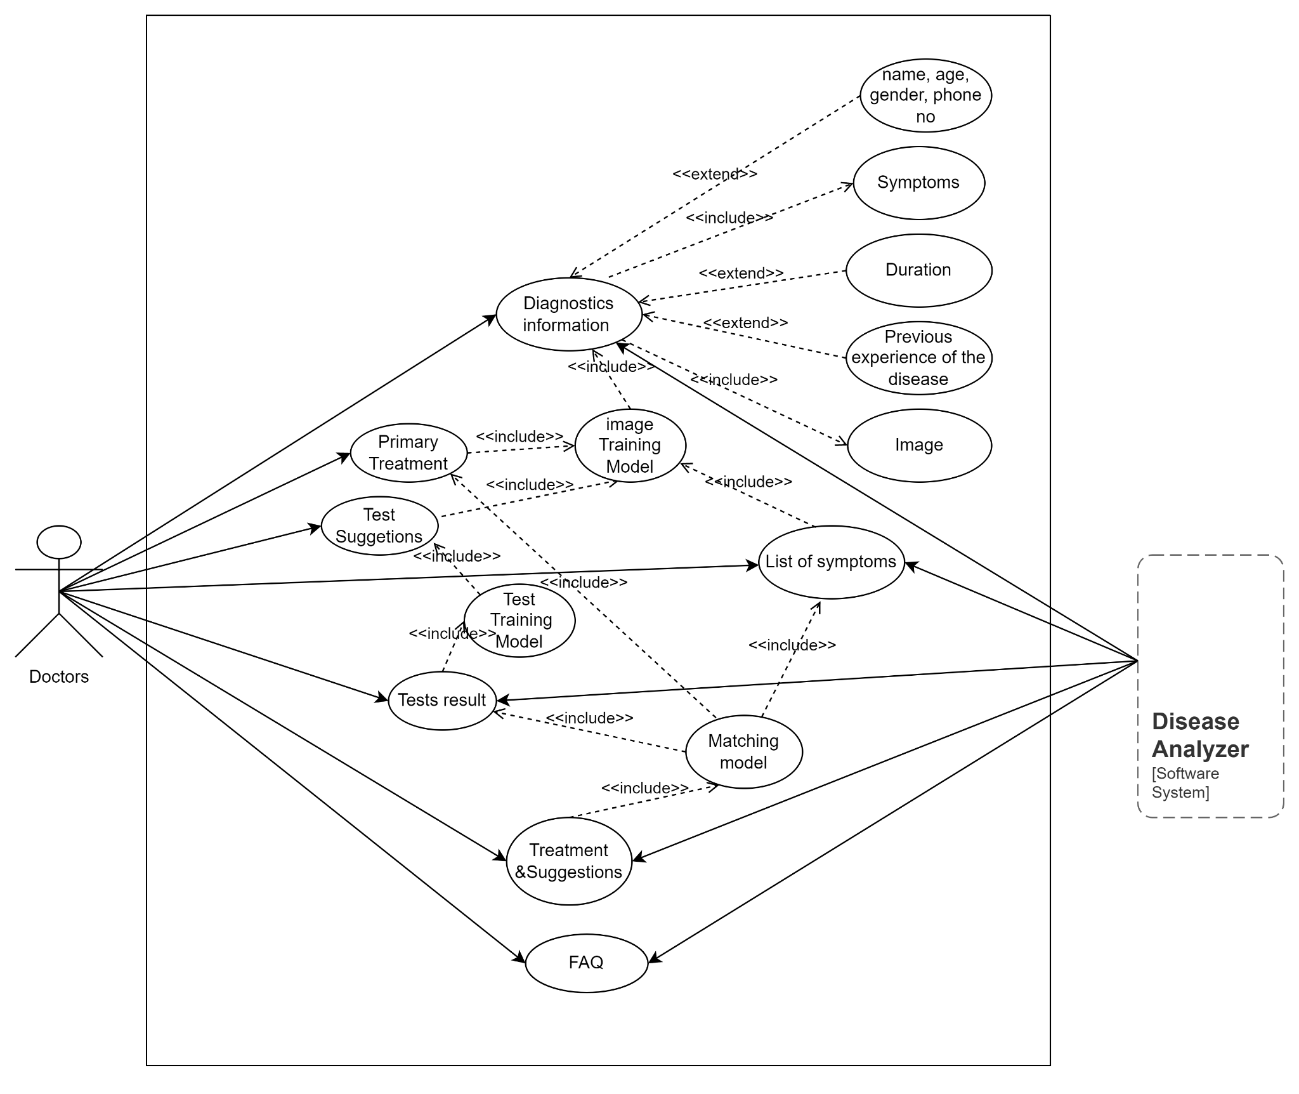

**3.3: Sequence Diagram**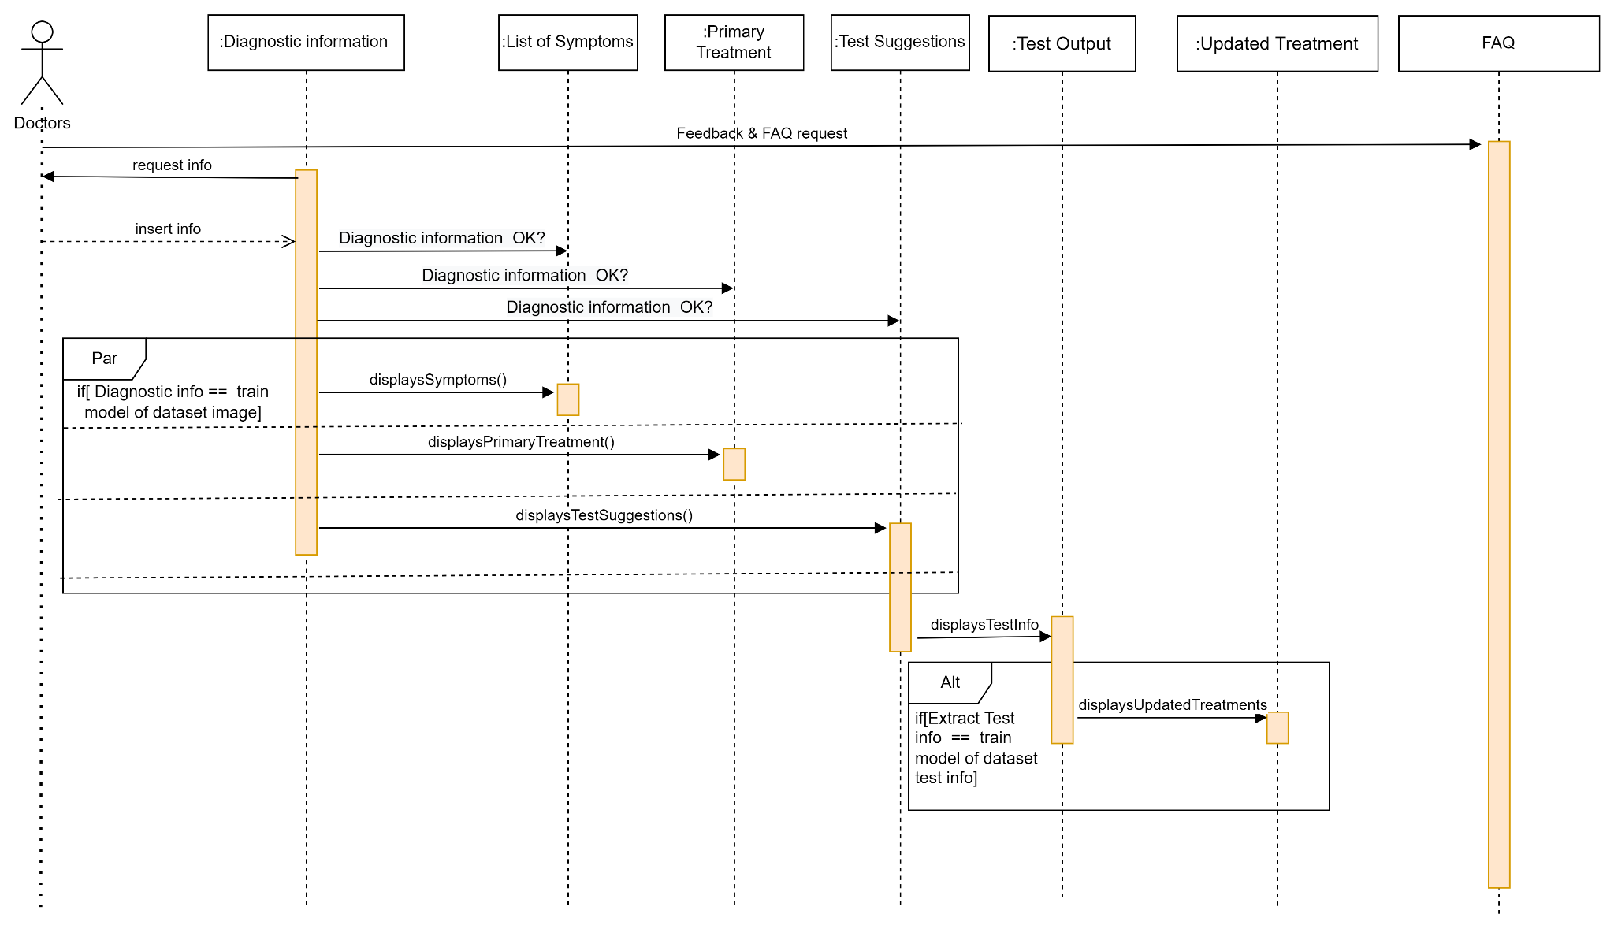

**3.4: Class Diagram**

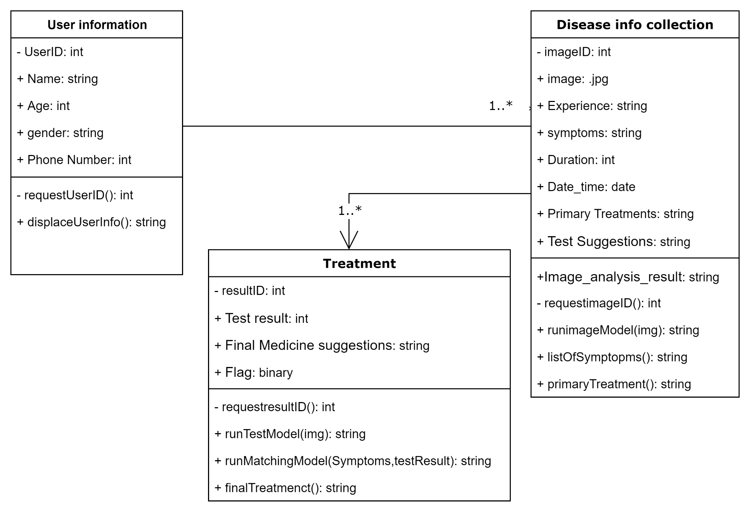

**4. Implementation: Prototype**

**Link: Figma prototype live link 🡪** [**Click Here!**](https://www.figma.com/file/kTT9xa1Sb958sgnqntK3bq/Untitled?node-id=0%3A1)

**Desktop – 01:**

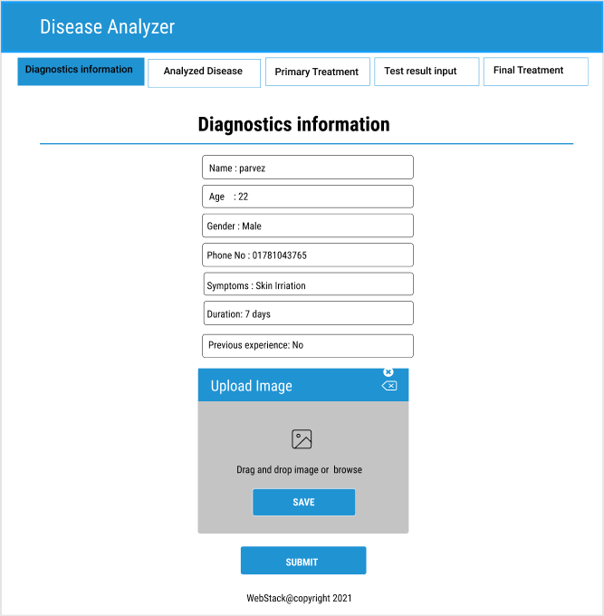

**Desktop – 02:**

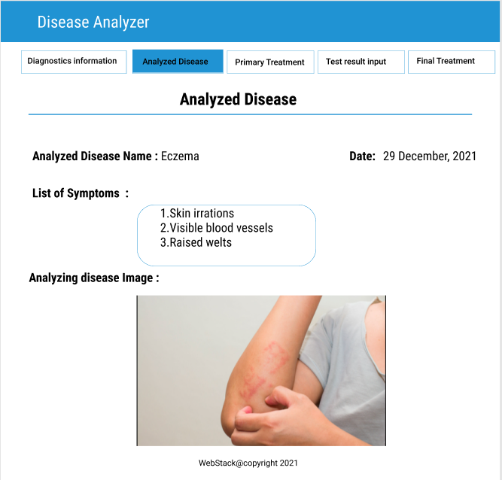

**Desktop – 03:**

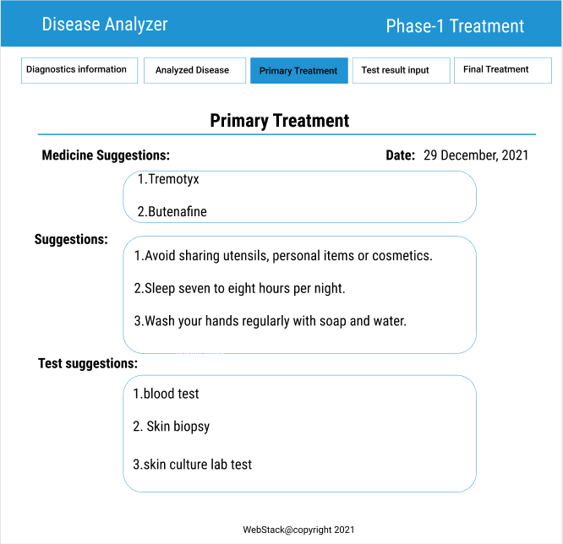

**Desktop – 04:**

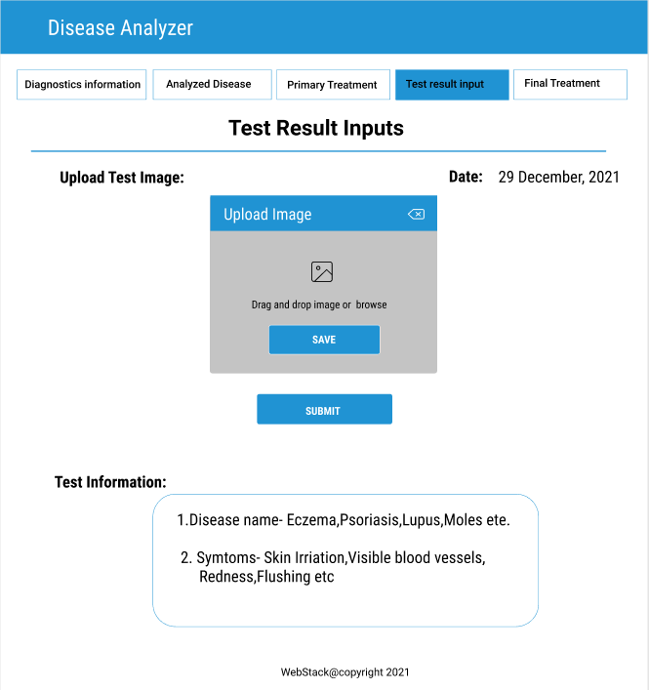

**Desktop – 05:**

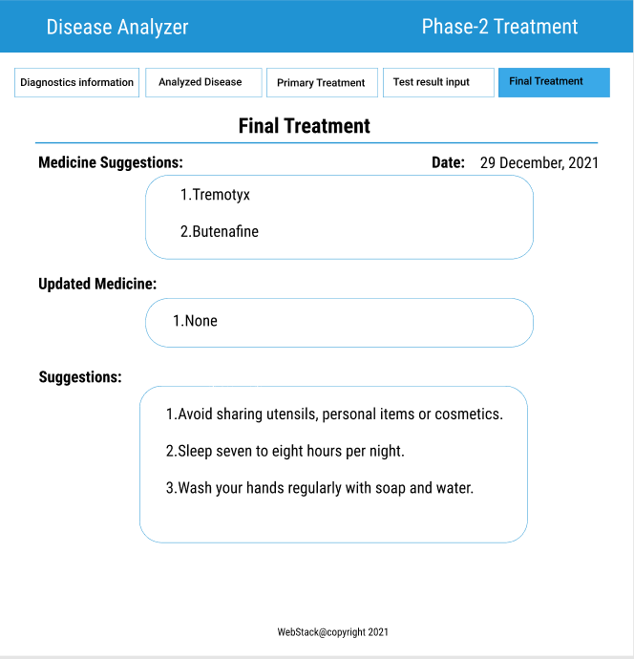

**5. Maintenance:**

**5.1: Maintenance:** Software maintenance is the general process of changing a system after it has been delivered. The term is usually applied to custom software in which separate development groups are involved before and after delivery. The changes made to the software may be simple changes to correct coding errors, more extensive changes to correct design errors, or significant enhancements to correct specification errors or accommodate new requirements. Changes are implemented by modifying existing system components and, where necessary, by adding new components to the system.

**5.2: Four major activities occur within maintenance:**

1. Obtaining maintenance requests 2. Transforming requests into changes 3. Designing changes 4. Implementing changes

Numerous factors influence the maintainability of a system. These factors, or cost elements, determine the extent to which a system has high or low maintainability. Of these factors, three are most significant: the number of latent defects, the number of customers, and documentation quality. The others—personnel, tools, and software structure—have noticeable, but less, influence.

* Latent defects. This is the number of unknown errors existing in the system after it is installed. Because corrective maintenance accounts for most maintenance activity, the number of latent defects in a system influences most of the costs associated with maintaining a system.
* Number of customers for a given system. In general, the greater the number of customers, the greater the maintenance costs. For example, if a system has only one customer, problem and change requests will come from only one source. Also, training, error reporting, and support will be simpler. Maintenance requests are less likely to be contradictory or incompatible.
* Quality of system documentation. Without quality documentation, maintenance efforts can increase exponentially. In other words, quality documentation makes it easier to find code that needs to be changed and to understand how the code needs to be changed. Good documentation also explains why a system does what it does and why alternatives were not feasible, which saves wasted maintenance efforts.
* Maintenance personnel. In some organizations, the best programmers are assigned to maintenance. Highly skilled programmers are needed because the maintenance programmer is typically not the original programmer and must quickly understand and carefully change the software.
* Tools. Tools that can automatically produce system documentation where none exists can also lower maintenance costs. Also, tools that can automatically generate new code based on system specification changes can dramatically reduce maintenance time and costs.
* Well-structured programs. Well-designed programs are easier to understand and fix.

**5.3: It is usually more expensive to add functionality after a system is in operation than it is to implement the same functionality during development. The reasons for this are:**

1. Team stability after a system has been delivered, it is normal for the development team to be broken up and for people to work on new projects. The new team or the individuals responsible for system maintenance do not understand the system or the background to system design decisions. They need to spend time understanding the existing system before implementing changes to it.

2. Poor development practice the contract to maintain a system is usually separate from the system development contract. The maintenance contract may be given to a different company rather than the original system developer. This factor, along with the lack of team stability, means that there is no incentive for a development team to write maintainable software. If a development team can cut corners to save effort during development it is worthwhile for them to do so, even if this means that the software is more difficult to change in the future.

3. Staff skills Maintenance staff are often relatively inexperienced and unfamiliar with the application domain. Maintenance has a poor image among software engineers. It is seen as a less-skilled process than system development and is often allocated to the most junior staff. Furthermore, old systems may be written in obsolete programming languages. The maintenance staff may not have much experience of development in these languages and must learn these languages to maintain the system.

We’ve all probably done it at some point: snapping a photo of a rash or a mole and sending it to a friend or colleague for advice on the “next steps”. But often the “next steps” may include confusion, uncertainty, or just plain fear.

So imagine if a system could guide you to a range of possible diagnoses, and provide you with a more realistic set of possibilities (as opposed to just guessing) on what the skin lesion may actually be.

Our system that has keenly aware of the need for teledermatology to enhance our lives. Every year over ten billion searches annually are made related to skin disease conditions that the natural progression was to take advantage of the high-resolution camera in your smartphone and harness the power of our system conduct a search of skin conditions.

Here’s how it works: After you launch the website, you use your phone’s camera to capture 1 image of the skin condition of vantage points. The website then asks you some questions about your skin type, the duration of the condition, and any other symptoms that may help to more accurately identify the condition. The app further analyzes this information and searches its database of 150 skin conditions to create a list of possible matching conditions.

## THE END